**Module -1 ( Fundamental )**

1. **What is SDLC**

**SDLC Is a Structure Imposed on the development of a software product that defines the process for planning, implementation, testing, documentation, deployment, and ongoing maintenance and support.**

1. **What is software testing ?**

# **Software Testing is a process Used to identify the correctness, completeness, and quality of developed computer software.**

1. **What is Agile method logy?**

**The Agile methodology is a project management approach that involves breaking the project into phases and emphasizes continuous collaboration and improvement. Teams follow a cycle of planning, executing, and evaluating.**

1. **What is SRS**

**Software Requirement Specification (SRS)**

**Software Requirement Specification IS a complete description of the behaviour of the system to be developed.**

**It includes a set of use cases that describe all of the interactions that the user will have with the software.**

1. **What is Oops**

**Objected Oriented Programing System : Black Box System.**

**Identifying objects and assigning responsibilities to these objects.**

**Objects Communicate to other objects by sending message.**

**Message are received by the Methods of an Object.**

1. **Write Basic Concepts Of Oops**

**Object**

**Class**

**Encapsulation**

**Inheritance**

**Polymorphism**

**Abstraction**

1. **What is Object**

**Object : Is a Instances of an Class**

**: to Create Memory for that Class to Access the Whole Properties from the except Private.**

**: Using new keyword and class constructor to create memory for object**

**SY:**

**Classname objectname = new classname ( ) / constructor () ;**

1. **What is Class**

**Class : is an collection of data member ( variable ) and member function ( process, methods ) with its behavior**

**SY :**

**Class classname**

**{**

**Data member ;**

**Member function**

**}**

1. **What is encapsulation**

**Encapsulation : data hide : wrapping of data into single unit i.e.**

**: private your data member and member fuction**

1. **What is inheritance**

**Inheritance : properties of parent class extends into child class**

**: properties of superclass extends into subclass**

**: main purpose is re usablity, extendsiblity etc…**

1. **Single : one parent having one child only**
2. **Multiple : single inheritance having one another child**
3. **Hierarchical : One parent having 2 or more child**
4. **Multiple : some language is not supported directly**
5. **Hybrid : some language is not supported directly**
6. **What is polymorphism**

**Polymorphism : ability to take one name having many forms/ multiple forms/ different forms**

**There are mainly 2 types**

1. **Compile time ( Method Overloading ) :**
2. **Run time ( method Overriding ) :**
3. **Draw Usecase on Online book shopping**

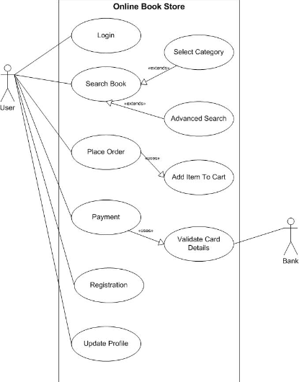

1. **Draw Usecase On Online bill payment system ( Paytm )**

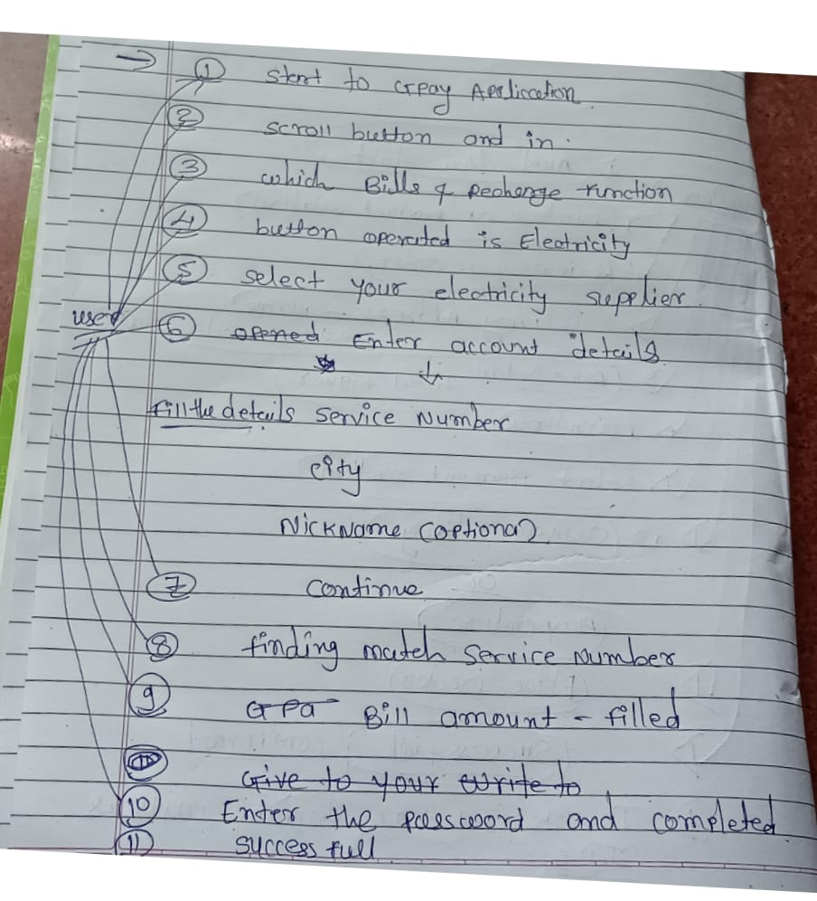

1. **Write SDLC Phases with basic Introduction**

**SDLC = SOFTWARE DEVELOPMENT LIFE CYCLE**

**SDLC PHASES : REQUIREMENT COLLECTION, ANALYSIS, DESIGN, IMPLEMENTION, TESTING, MAINTENANCE**

1. **REQIREMENT COLLECTION : Features,**

**Usage scenario, Although requirement may be documented in Written form they may**

**Requirements Will be change**

**Plan for change**

**Early prototyping**

**Functional – Non Functional**

**Lack of clarity , Requirement confusion, Requirement Amalgamation**

1. **Analysis Phase : The Analysis Phase Defines the Requirement of the system, independent of how these requirements Will be Accomblishd**

**This document state in clear and precise**

1. **Design Phase : Design architecture Document, Implementation Plan, Critical Priority Analysis, Performance Analysis, Test Plan**
2. **Implementation Phase : In the Implementation Phase, the Team builds the components either document from the design Phase and the requirement document from the analysis phase, the team should build exactly what has been requested, thought there is still room for innovation and flexibility.**

**Implementation – code**

**Critical Error Removal**

1. **Testing Phase : simply tested quality is very important. Many Companies have not learned that qualityis important and deliver more claimed functionality but at a lower quality level.**

**Updating all analysis, design and user documentation**

1. **Maintenance : Maintenance is the process of Changing a system after it has been deployed**

* **Corrective maintenance**
* **Adaptive Maintenance**
* **Perfective Maintenance**

1. **Explain Phase of the Waterfall model :**

**The waterfall model is a project management workflow that breaks down development activities into sequential phases. The phases are passed down to each other, and each phase depends on the deliverables of the previous one. The model originated in manufacturing and construction, but is also used in software development and engineering design**

1. **Write Phases Of Spiral Model**

**The planning of objectives, risk analysis, engineering or development, and finally review.**

1. **Write Agile manifesto Principles**

**The Key Values and Principles of the Agile Manifesto**

**Individuals and interactions over processes and tools.**

**Working software over comprehensive documentation.**

**Customer collaboration over contract negotiation.**

**Responding to change over following a plan**

1. **Explain Working methodology of agile model and also write pros and cons.**

**The Agile methodology is a project management approach that breaks projects into phases, or sprints, and emphasizes continuous collaboration and improvement. The Agile framework is iterative, and teams reflect and adjust their strategy after each sprint.**

**Agile model pros**

* **Is a very realistic approach to software development**
* **Promotes teamwork and cross training?**
* **Resources requirement are minimum**
* **Suitable for changing requirement**
* **Minimal rules, documentation easily employed.**

**Agile model cons**

* **Not suitable for handling complex dependencies**
* **More risk of sustainability, maintainability and extensibility.**
* **An overall plan, an agile leader and agile PM practice is a must without which it will not work.**
* **Strict delivery management dictates the scope, functionality to be delivered, and adjustments to meet the deadlines.**

1. **Draw Use case on online Shopping product using COD.**

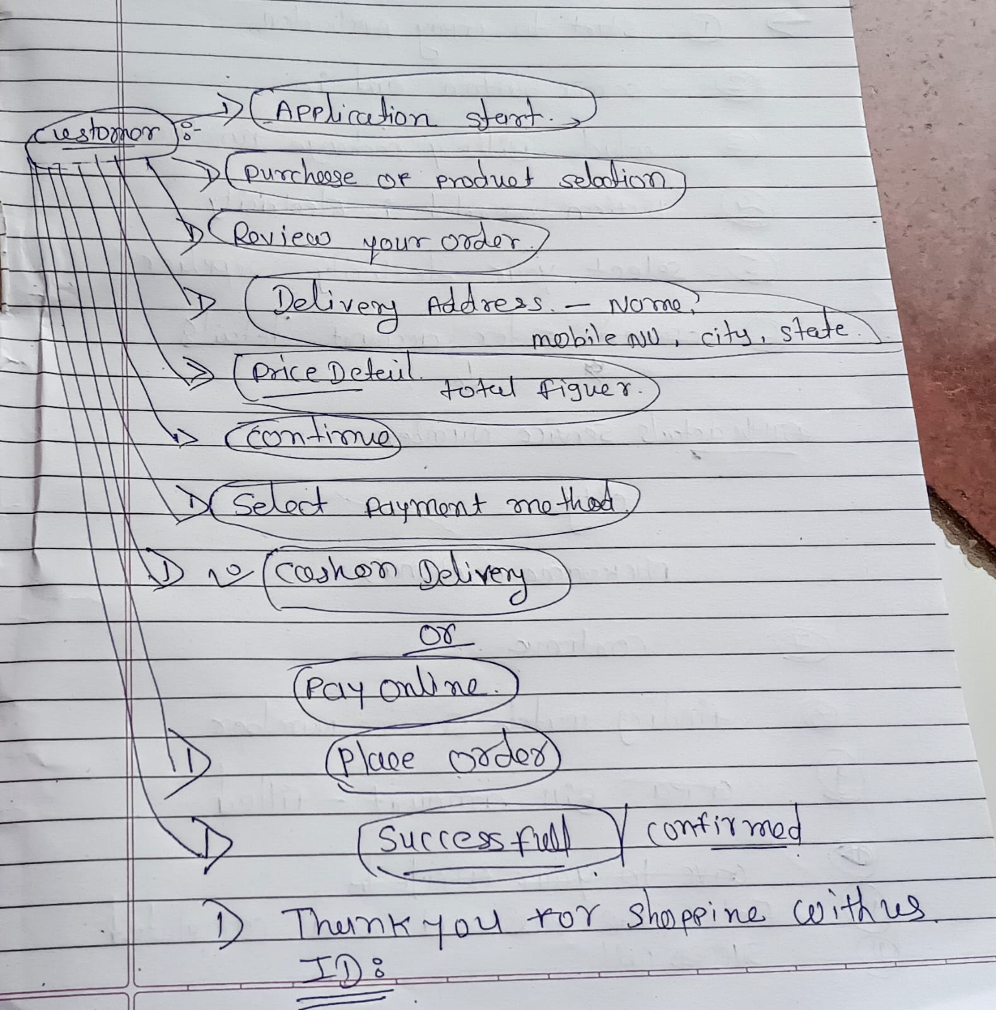

1. **Draw Use case on online shopping product using payment gateway.**

